The Open Voice Factory User manual

Aideen Lynam



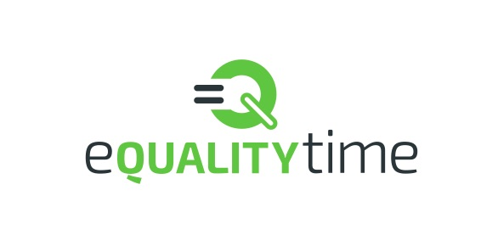

Version 1.0

Table of Contents

About the Open Voice Factory 3

History of the Open Voice Factory 5

Why the Open Voice Factory? 6

Step by step guides 8

Guide 1: The basics of creating an online communication device 8

Guide 2: Adding pictures and new utterances 16

Guide 3: How to delete links to a page 20

Guide 4: Adding new pages 22

Guide 5: Creating/Updating Links 26

Guide 6: Special commands on iOS Mac Device 31

Guide 7: Special commands on Windows Device 32

Other Open Projects 34

Appendix 34

References 36

# About the Open Voice Factory

The Open Voice Factory is open source project that allows for the creation of online communication devices from PowerPoint templates.

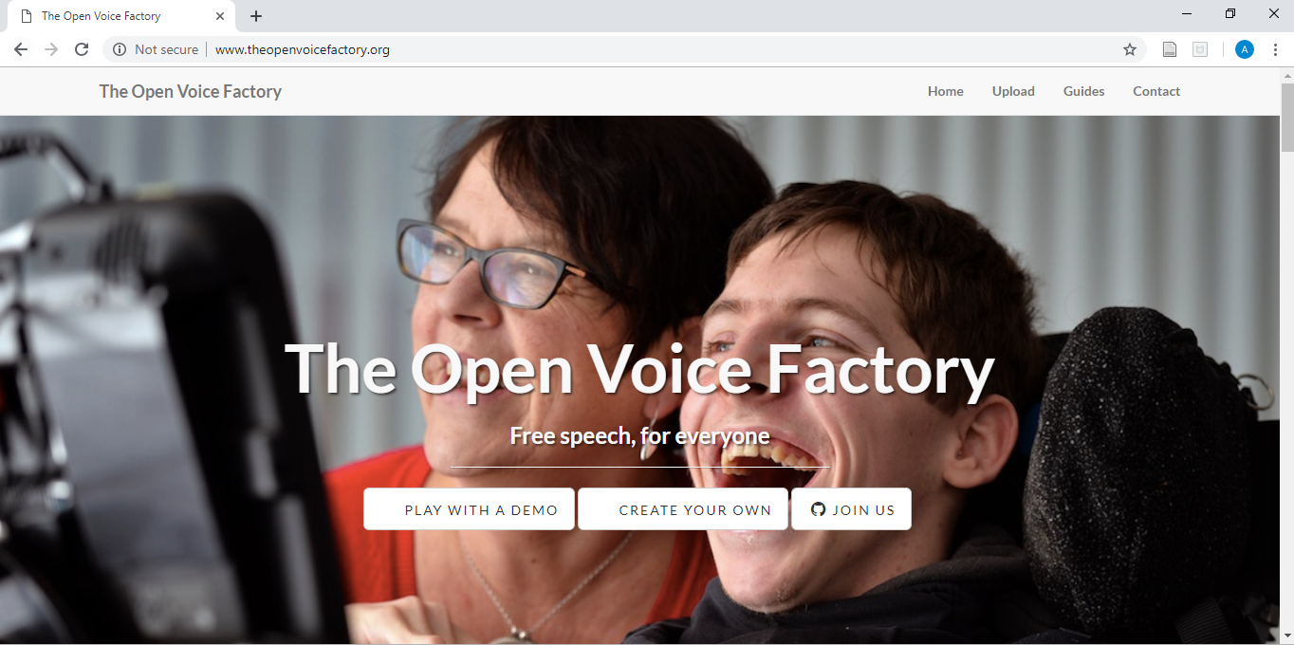

Figure 1: Open Voice Factory website

The idea for open access software to create an online communication device came about because high tech augmentative and alternative communication (AAC) devices can be difficult to source. A lot of individuals may benefit from having access to a device which facilitates their communication but struggle to find the funds for such a device. Up to 15 in every 1,000 children have such severe speech-language impairments that they have difficulty making themselves understood. This affects all aspects of the individual’s life, from daily activities like playing with other children and taking part in school to talking to a doctor about symptoms or to family members about their hopes and dreams.

Electronic speech aids, which ‘speak’ set words or phrases when a sequence of symbols are pressed, can be life-changing for these children. However, current devices are expensive even in economically developed countries and accessing the funds needed to buy a device can be difficult.

The Open Voice Factory provides free speech aid software by converting communication boards into communication devices. Anyone can create an aid by editing a PowerPoint communication board template to add their own pages or utterances. When you upload your template to the factory, it will create a working communication aid for you. The resulting programs run on any platform, from tablets to laptops to phones, without installation or complex setup. It is worth noting that currently the aids that the Open Voice Factory builds need an internet connection to work properly.

Everything created is free- free as in ‘don’t pay for it’ and free as in speech. All of the code is freely available on GitHub [here](https://github.com/eQualityTime/TheOpenVoiceFactory) and anyone can change or repurpose without having to ask first. The Open Voice Factory is supported by the volunteers who write the code, create the templates and help out all over.

The Open Voice Factory [website](http://www.theopenvoicefactory.org/) has information on how to create your own device, as well as an opportunity to try out a demo communication device and find out how you can help.

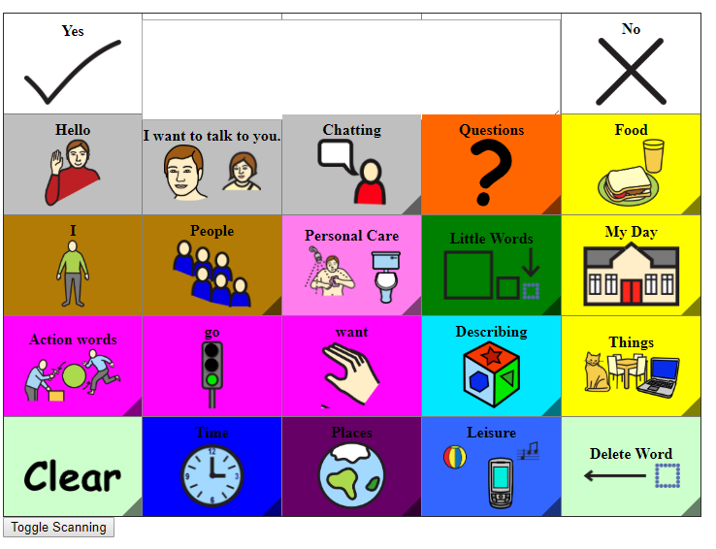

Figure 2: Demo of CommuniKate 20 on the Open Voice Factory

The most important thing to remember is to test the online communication device you create thoroughly. There may be bugs lurking in the code and the last thing we want is one to appear in an emergency.

The Open Voice Factory is currently in Beta – it is for testing only and not recommended for deployment with users just yet. At this stage of development, anyone with the correct link is able to view your files, so keep this in mind before uploading any private content.

# History of the Open Voice Factory

The Open Voice Factory started out as a software named AzuleJoe, with origins dating back to 2009 when it was created by Joe Reddington who created it for his little brother. The software was significantly overhauled in the preparations for the public release of CommuniKate 20 in 2014. Originally a minimalist open source viewer for the CommuniKate 20 page set, the software was designed to run the CommuniKate 20 page set online and allow for a freely accessible voice output communication device with a dynamic display to be used by anyone who needed it. It received another major production overhaul during the Nesta Challenge Prize in 2016, which funded the development of some of its most significant features. As it’s community grew and the demands on it increased, the project was again picked up by a funder who saw its and it became one of Comic Relief’s Tech for Good Cohort in 2018.



Figure 3: Joe's little brother and his device.

# Why the Open Voice Factory?

The Open Voice Factory is completely free to use. This means that users have easy access to an online communication device when they need it. There are a lot of individuals who could benefit from a device like the one the Open Voice Factory creates.

Creer, Enderby, Judge and John (2016) conclude that 536 people in 100,000 of the UK population, approximately 0.5%, could benefit from AAC. Further research found that 0.05% of the UK population could benefit from a high tech AAC device, however it was found that only 0.014% of the population has access to a high tech aid . This difference of 0.036%, or over 23,000 people, demonstrates that there are many individuals who are without a functional communication device, the main reason being cost (or specifically access to funding).

That’s over 23,000 people who have difficulty choosing what to have for breakfast, participating in the classroom or chatting with their family. And those 23,000 people are just in the UK alone. The Open Voice Factory has been designed so that it can be used by anyone who needs and could benefit from it, regardless of cost. The only thing required is a device (any device) with internet access to run the online communication device the Open Voice Factory creates. The open access software means you can download and modify it in anyway you choose to make it work for you or someone else who needs it.

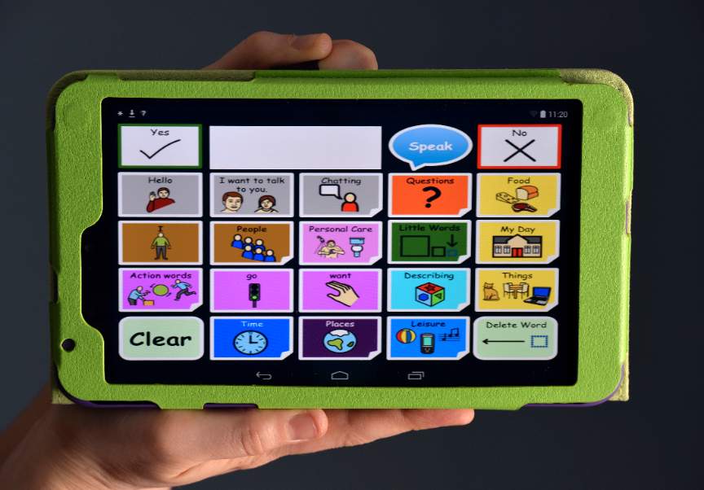

Figure : CommuniKate 20 created by the Open Voice Factory running on a tablet device.

The Open Voice Factory allows users, SLTs and members of the care network to examine the layout and style of the online communication device without any inconvenience to the user. The Open Voice Factory also allows for easy modelling of the vocabulary. For example, the same page set can be present on two different devices at the same time allowing a parent, teacher, sibling, SLT, care worker, whoever, to model the vocabulary on a device separate to the user’s one without any installation, complex set up or extra cost. The user will still get the benefit of having the vocabulary modelled for them, while retaining their device so that they too can participate in the conversation.

Moreover, AAC devices can unfortunately break, and may require long periods of time to be repaired (Ball et al., 2007; Shepard et al., 2009). The Open Voice Factory can be accessed through a variety of devices, so long as there is an internet connection, meaning that the time spent without a device is reduced and there is no need to use a different vocabulary layout in the interim.

# Step by step guides

Here are some step by step guides on how to use the Open Voice Factory. If you would prefer to watch a video and follow the steps that way, you can find all the corresponding videos [here](http://www.theopenvoicefactory.org/guides.html). The screenshots below are from a windows device, however the process is the same for a Mac device.

## Guide 1: The basics of creating an online communication device

1. Open Voice factory website- [www.theopenvoicefactory.org](http://www.theopenvoicefactory.org)

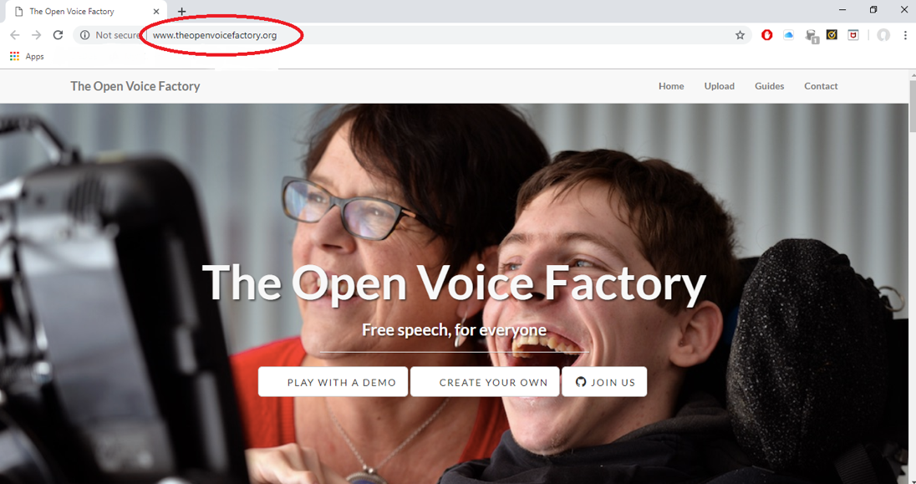

1. Click create your own.

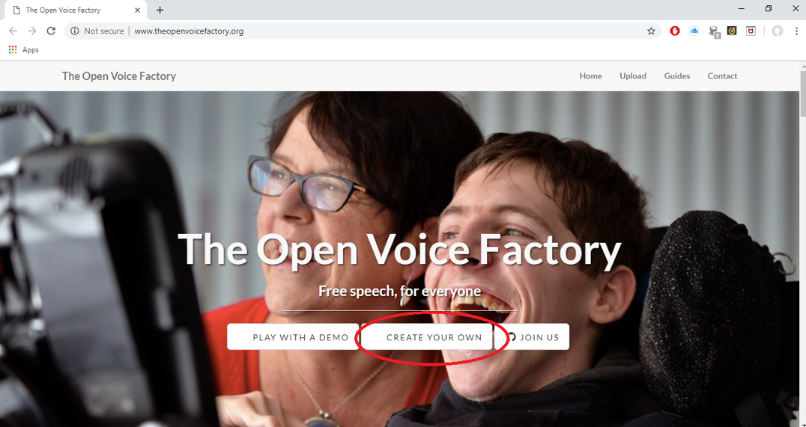

1. Go to the Upload page, through the link in the final paragraph.

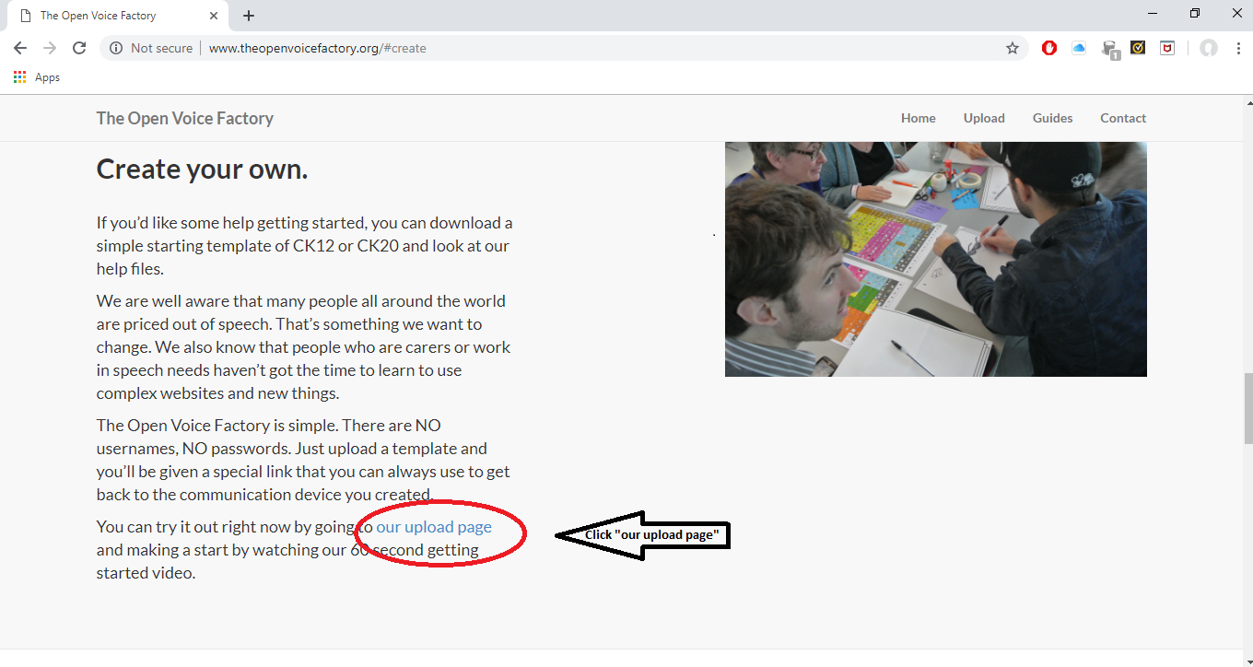

1. There is a 3 minute video that you can watch. The following steps of this guide are demonstrated in the video, so you can decide whether you want the video support to help you create your device or if the information and images below are enough.

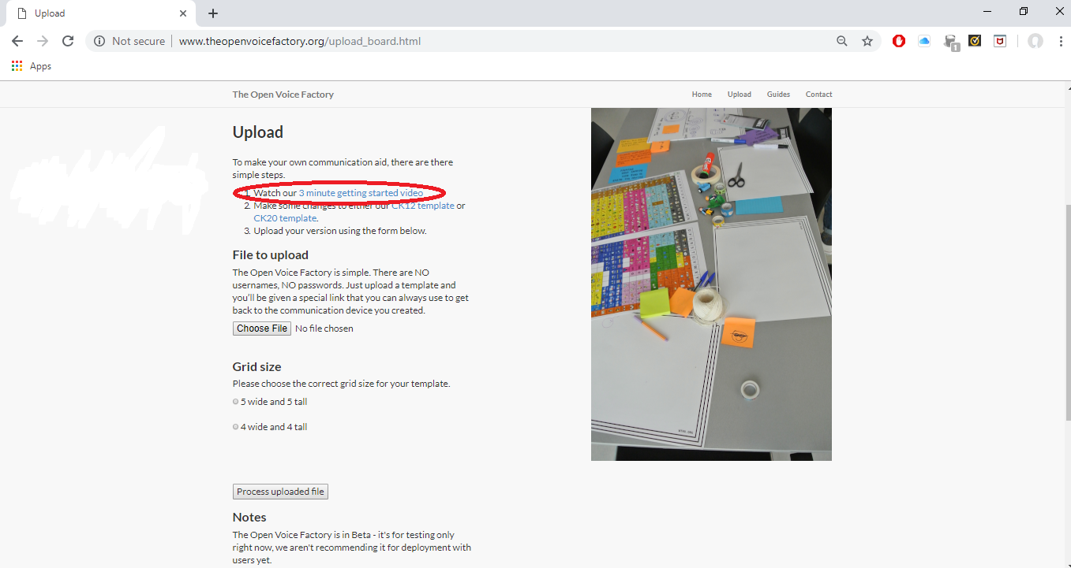

1. Download the CommuniKate template you would like to work from. See the CommuniKate manual **(LINK)** for more information on both page sets and to help you decide which would best suit the person who will be using the device.
   1. The templates are in PowerPoint format. This format was chosen as PowerPoint is universal and easy for people to use. Each slide in document becomes page in page set you will create. Make sure to select ‘Enable editing’ if required to make any edits.

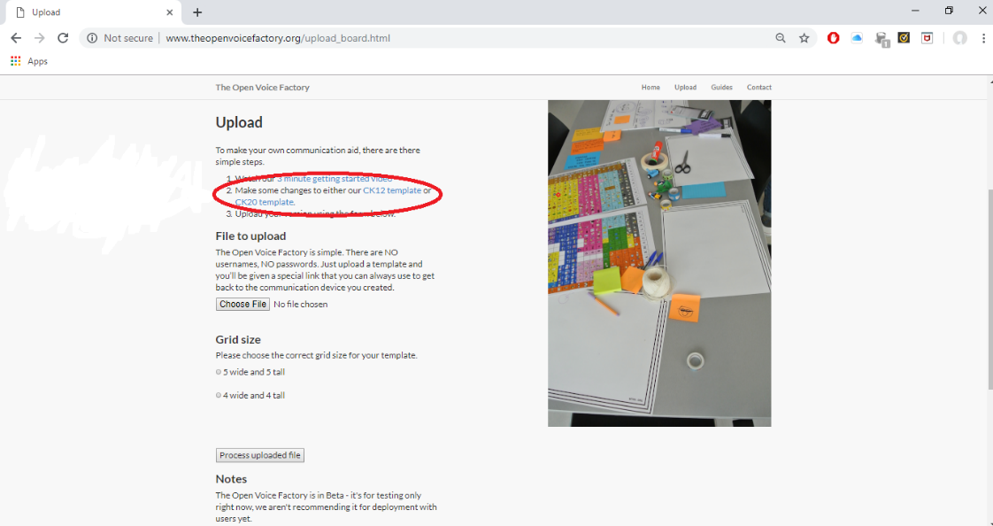

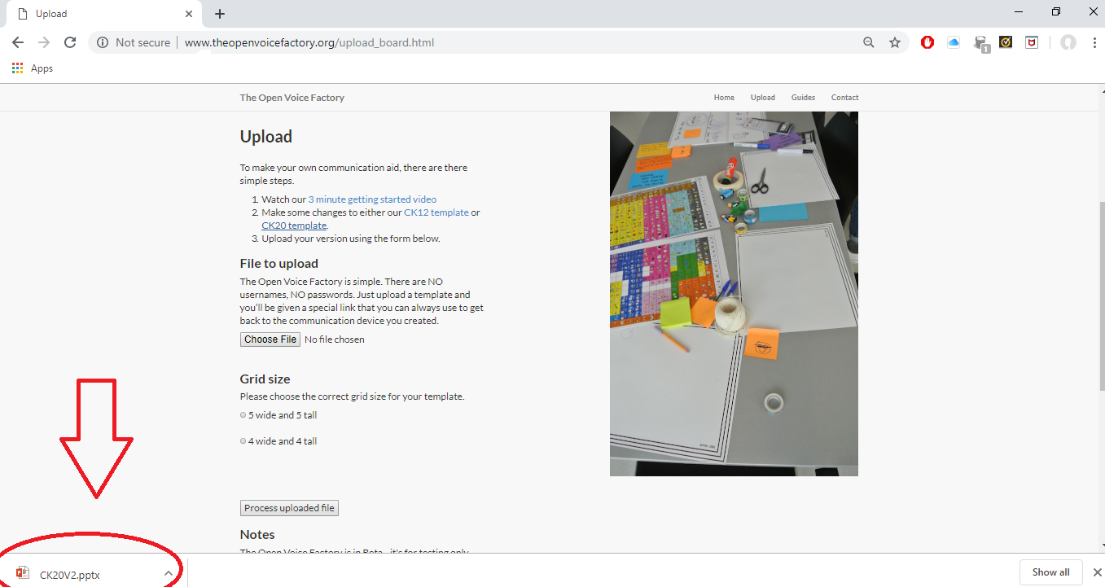

1. You use this template to make any changes you require to the vocabulary present for the device, for example adding specific people or places important to the person who will be using AAC. See the other step by step guides for more information on this.
   1. There are lots of pages in the template, for example one for questions, some for places, some for people. The CommuniKate manual has information on what pages are present in each template.

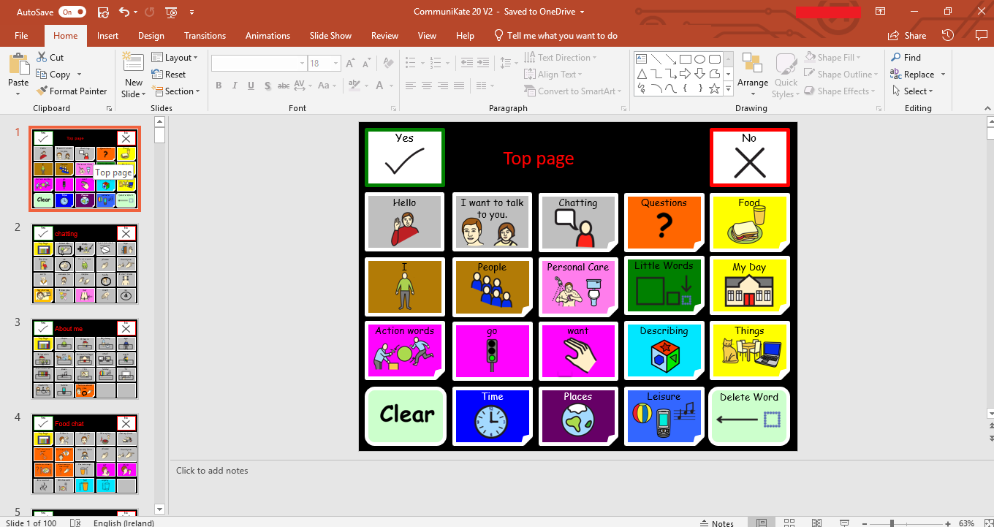

1. Save the file into a specific location, for example *My Documents*, and go back to the Open Voice Factory website.

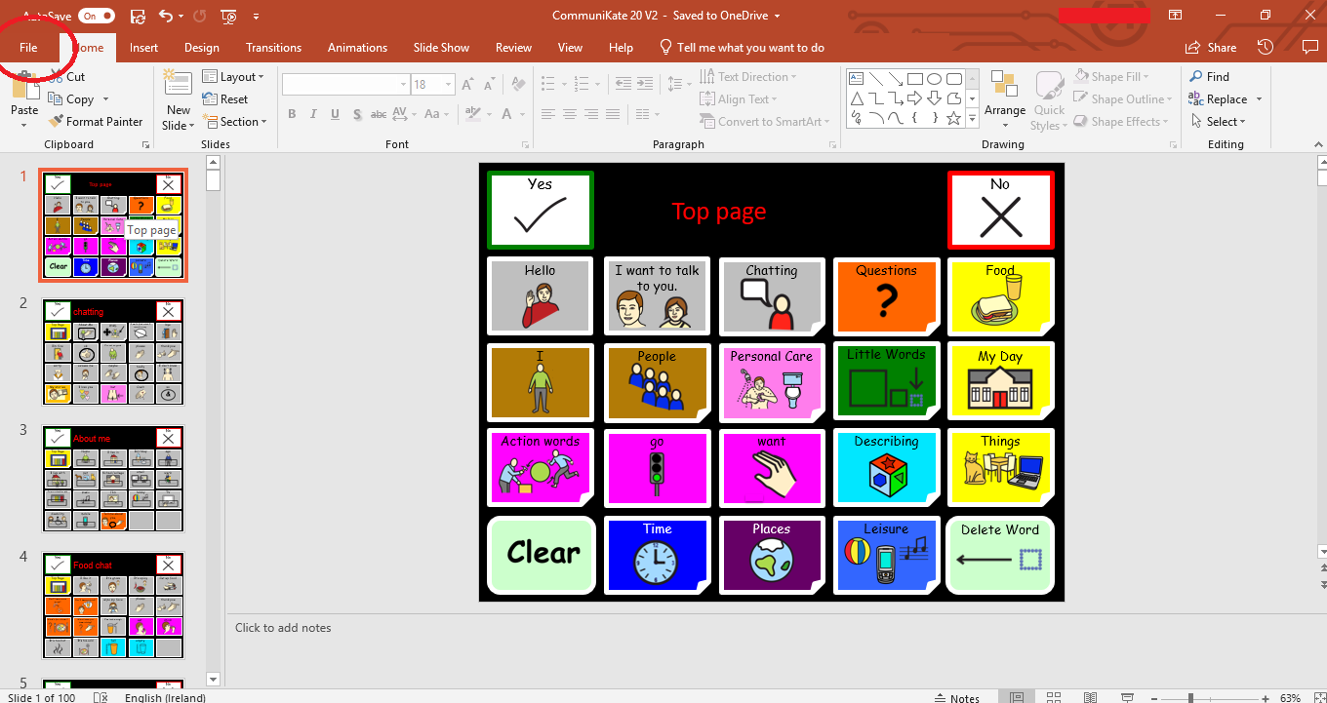

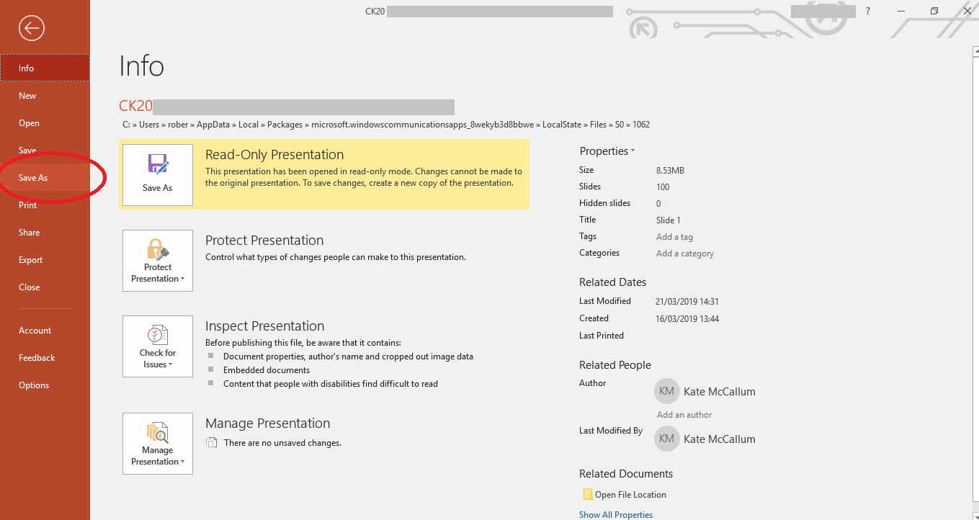

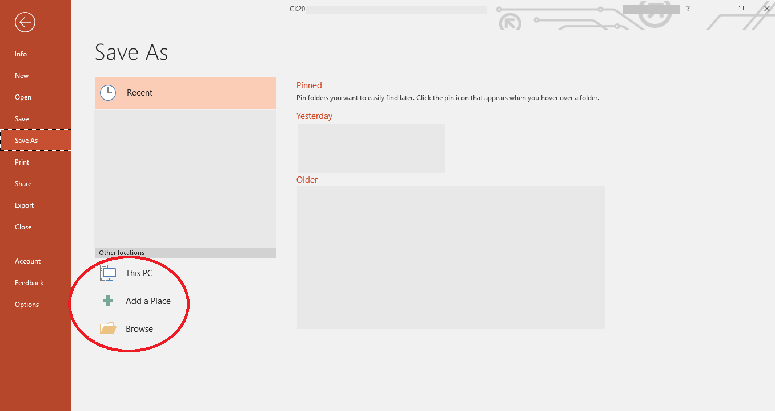

1. Upload the edited file to the website.

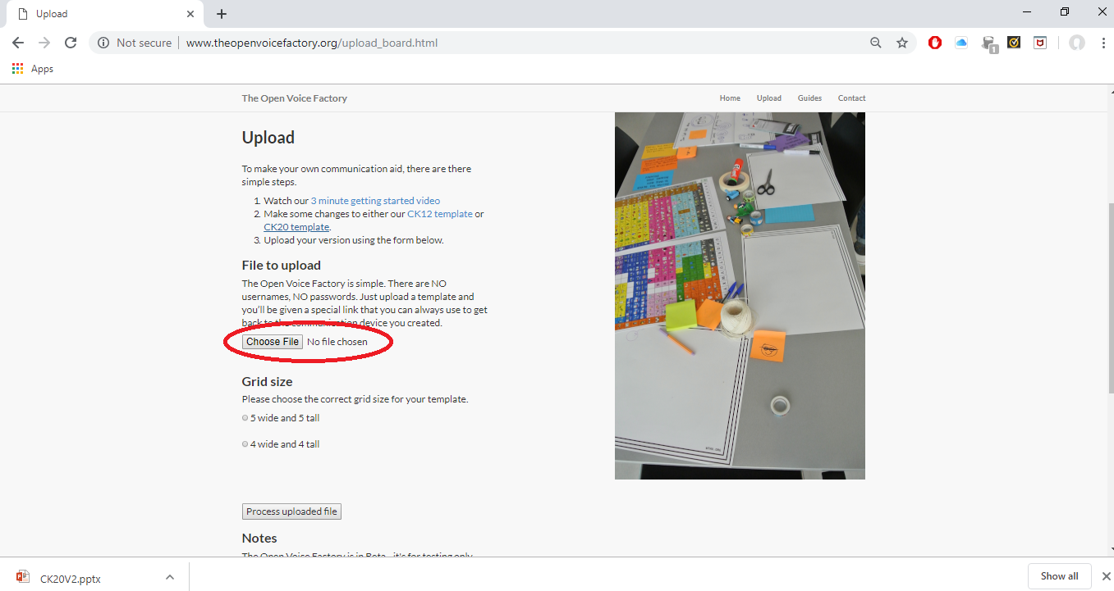

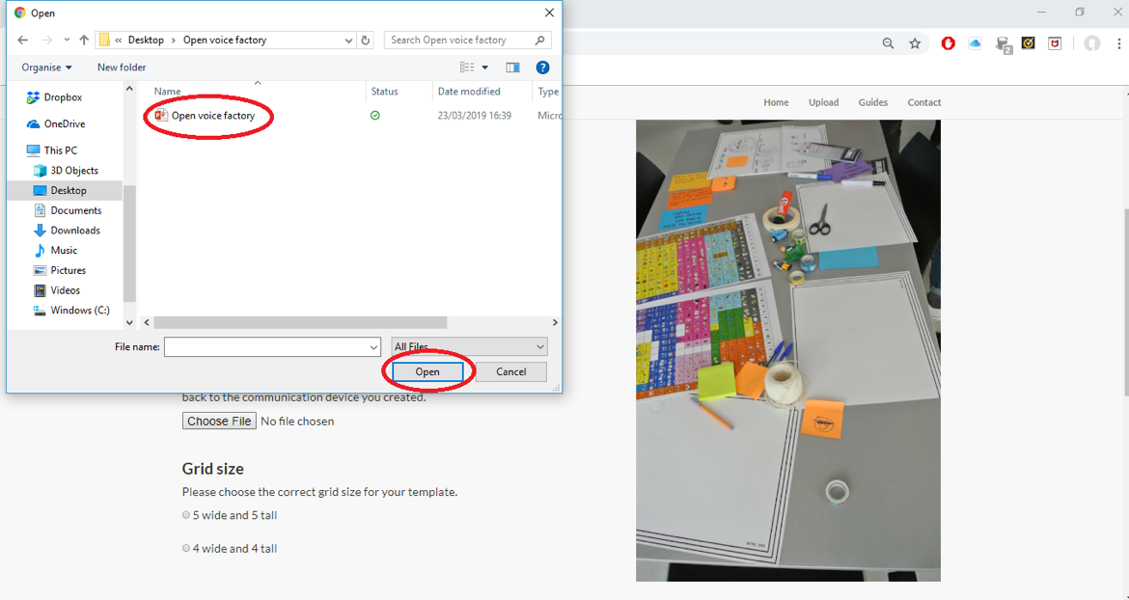

1. Chose the correct Grid size for your template - CommuniKate 20 is a 5x5 grid and CommuniKate 12 is a 4x4 grid.

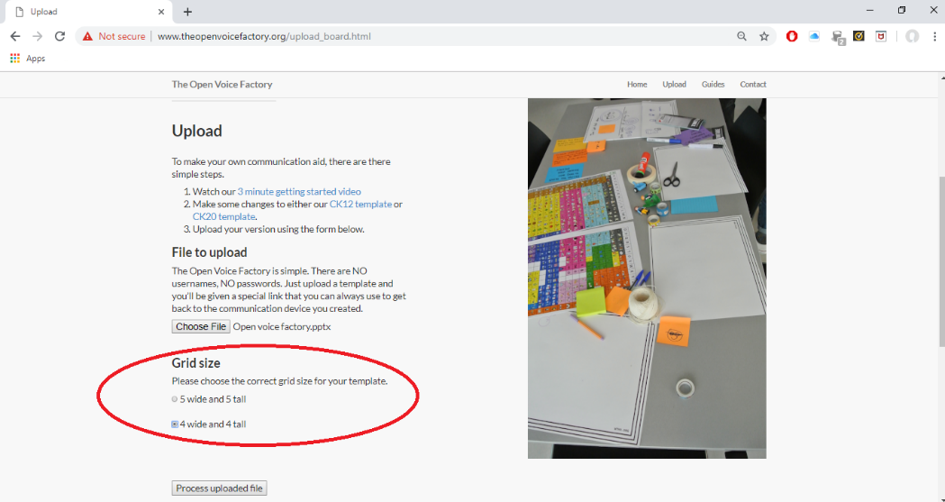

1. Click ‘*Process uploaded file’.*
   1. It will take a few seconds for file to be uploaded and processed on the server.

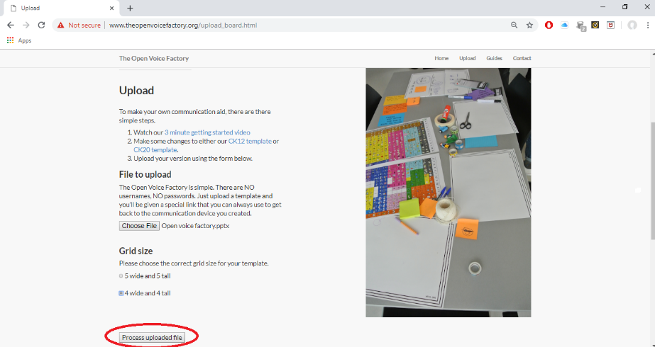

1. When the Open Voice Factory is finished processing your file, it will take you to a new page with some diagnostic information on it and will include the link to your new communication device.
   1. What the Open Voice Factory has done here is create an entirely new communication device from your template. It has then placed that online device at a unique web address. This is the web address that you give to anyone who wants to use the device. They can use the device you’ve created straight away, without any user names, payments or passwords.

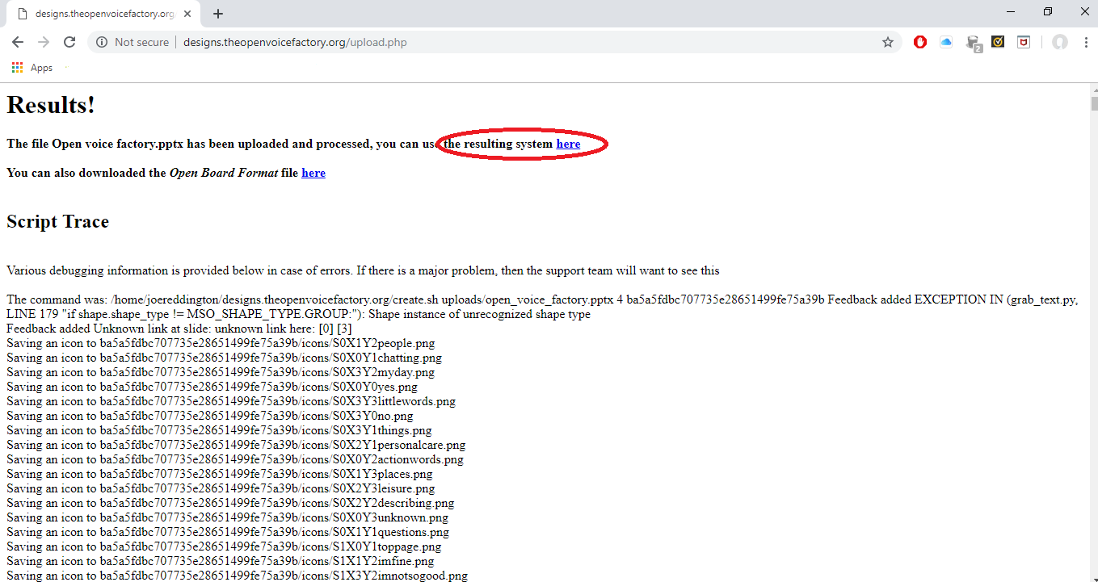

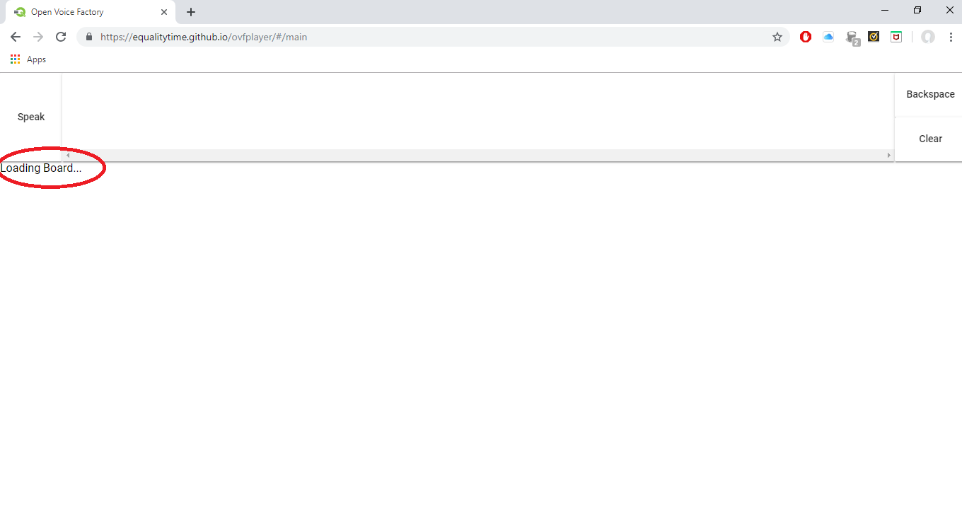

1. Click on the link and you will be taken to the online communication device. The online device has the changes you made, provided you uploaded the correct file, and works like an online communication device is expected to.

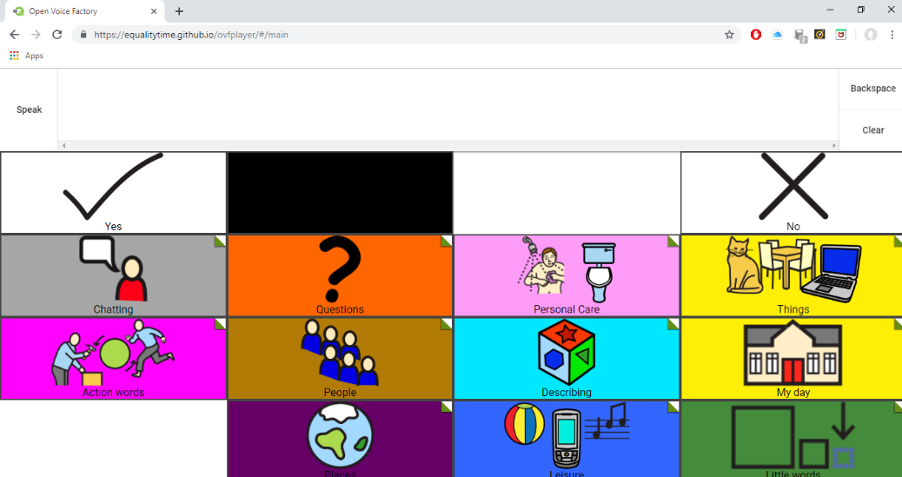

1. The unique web address is in the address bar. Save the link in a safe place so that it can be shared with others as required.

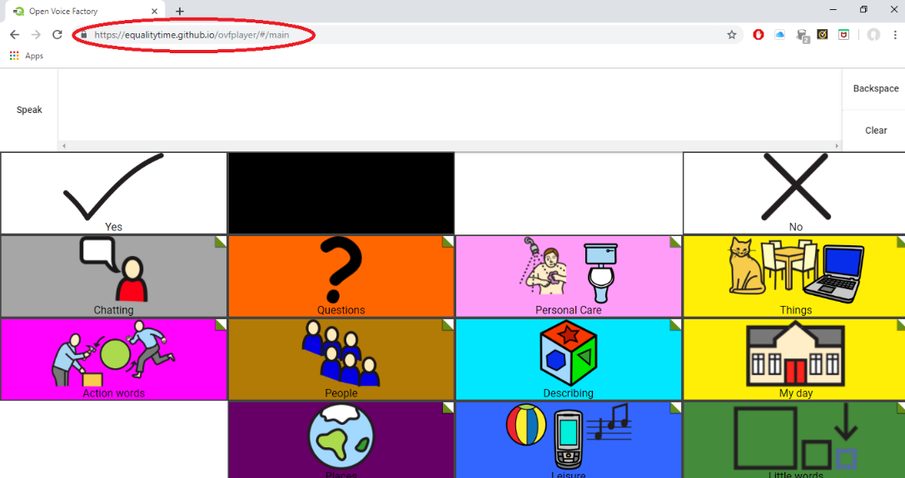

## Guide 2: Adding pictures and new utterances

1. Open the CommuniKate PowerPoint template downloaded from the Open Voice Factory [website](http://www.theopenvoicefactory.org/). If you are making further edits to a document which you have already made changes to, open the last document you had saved to your computer.



1. Open page you would like to edit, for example the fizzy drink page on your template document.

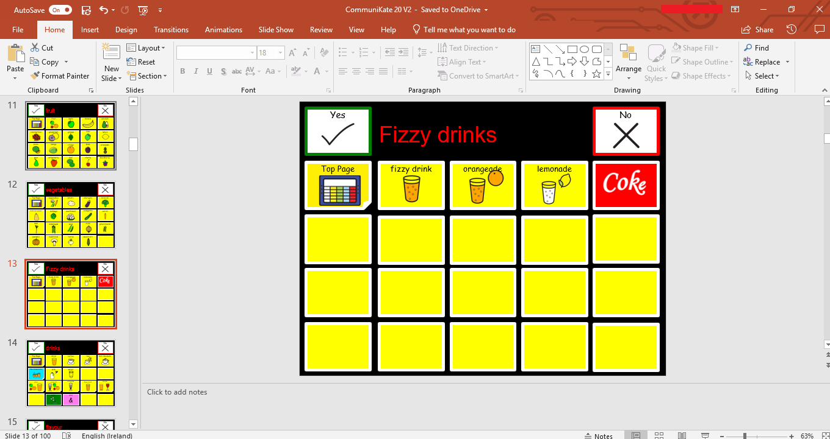

1. Each square in the slide has a piece of text, i.e. the utterance and an icon

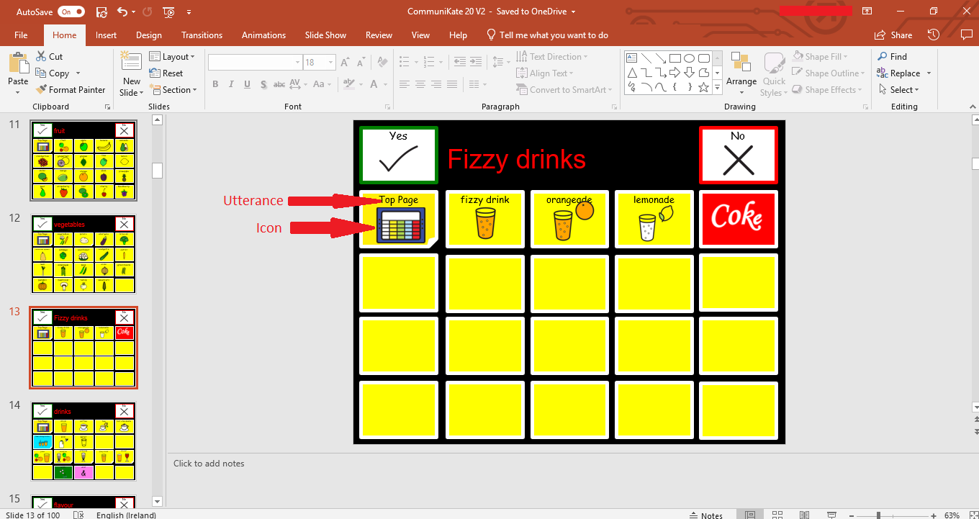

1. To create a new symbol, copy and paste a text box from a previous symbol into a blank square.
   1. You can also create a new textbox and position it correctly in the square. However, if you do this, you must then change the font type and size to match the rest of the page set, so generally it is easier to just copy and paste!

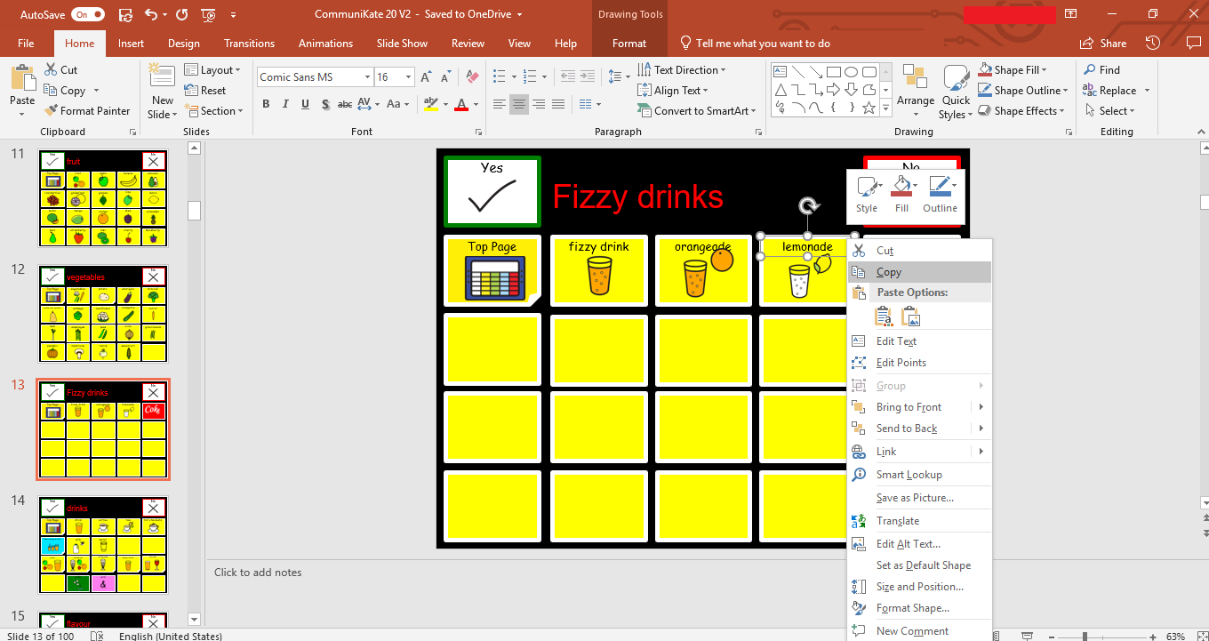

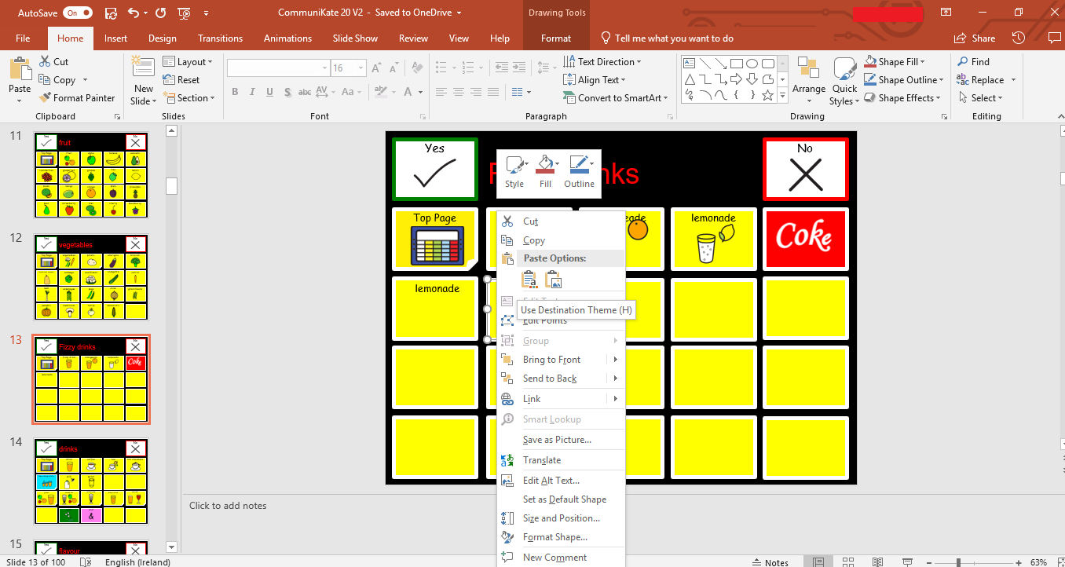

1. Edit the text to the utterance you would like the symbol to say.

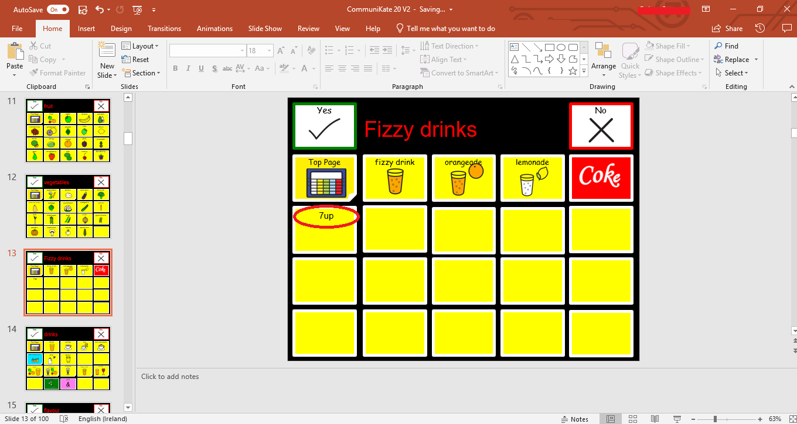

1. Next, add an appropriate picture or icon.
   1. You can use google to search for an image, use a picture already on your computer (i.e. from a phone picture), screenshot something from a website or use the symbol pictures used across the rest of the page set, [mulberry symbols](https://mulberrysymbols.org/). See the CommuniKate manual for more information on this symbol set (**http://communikate.equalitytime.co.uk/).**

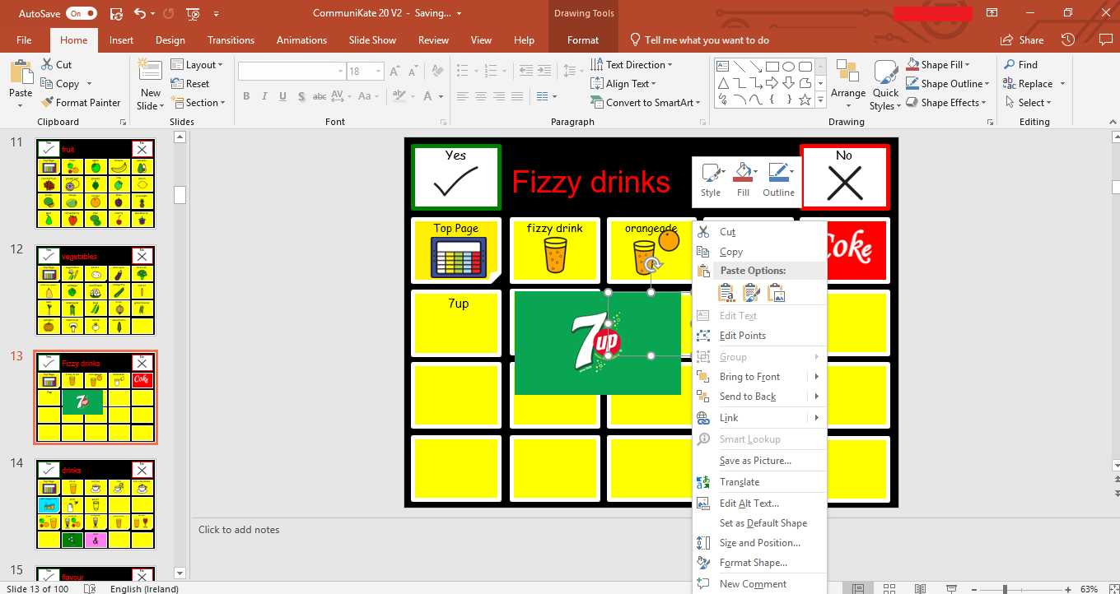

1. Alter the image to fit the box as needed.

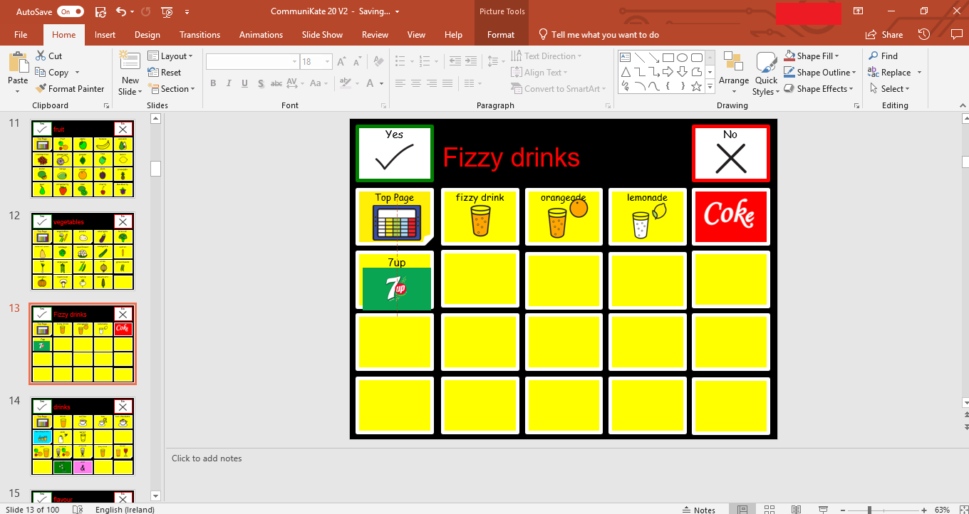

1. Once you are finished all your edits, save the template.
2. Go to the Open Voice Factory website. As the file has been changed it must be reuploaded.
   1. See Guide 1 for more information on uploading a file.
3. Open the link and the new symbols you have added will be present.

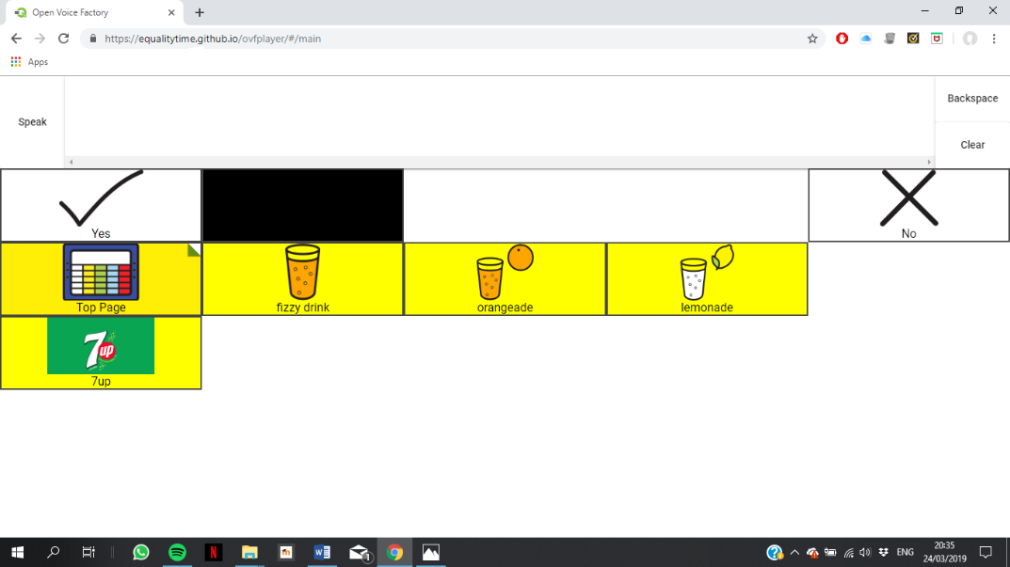

## Guide 3: How to delete links to a page

Link pages are represented in the CommuniKate templates as boxes with a folded corner. To find out where the symbols links to, right click the box and choose edit link/ edit hyperlink.

To delete a link follow the steps below. You do not have to delete the entire page, but rather can delete the links to it. This means the page can be re-added at a later date if it is required.

1. Open the CommuniKate PowerPoint template downloaded from the Open Voice Factory [website](http://www.theopenvoicefactory.org/). If you are making further edits to a document which you have already made changes to, open the last document you had saved to your computer.



1. Identify the box which links to the page you would like to delete.

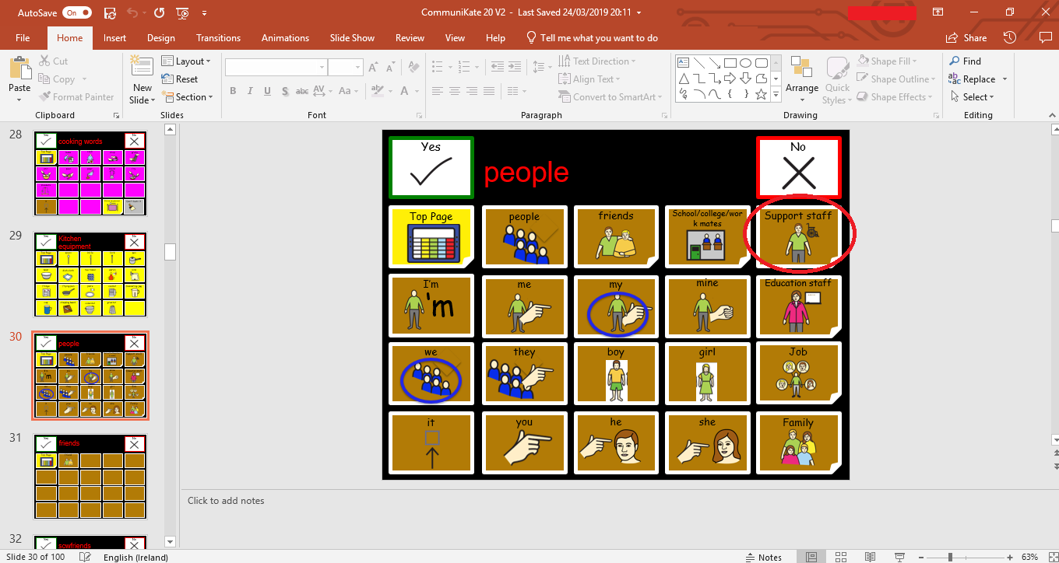

1. Delete the text and icon of the link box and then the box itself.

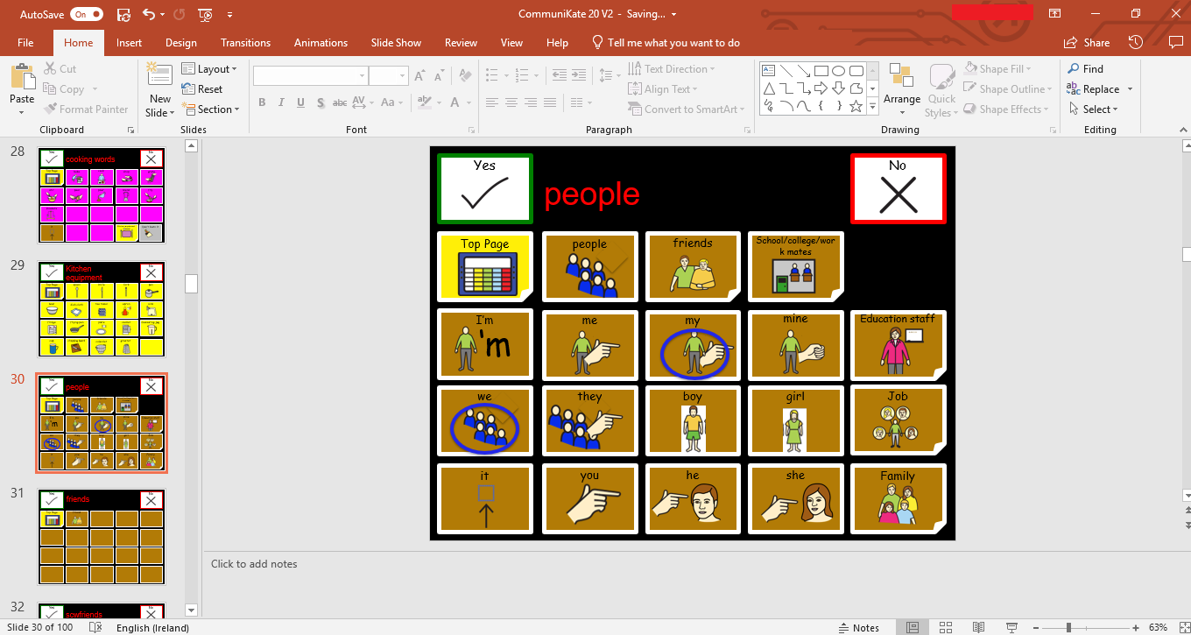

1. Replace the deleted link box with a normal utterance box, copied and pasted from another on the same slide.

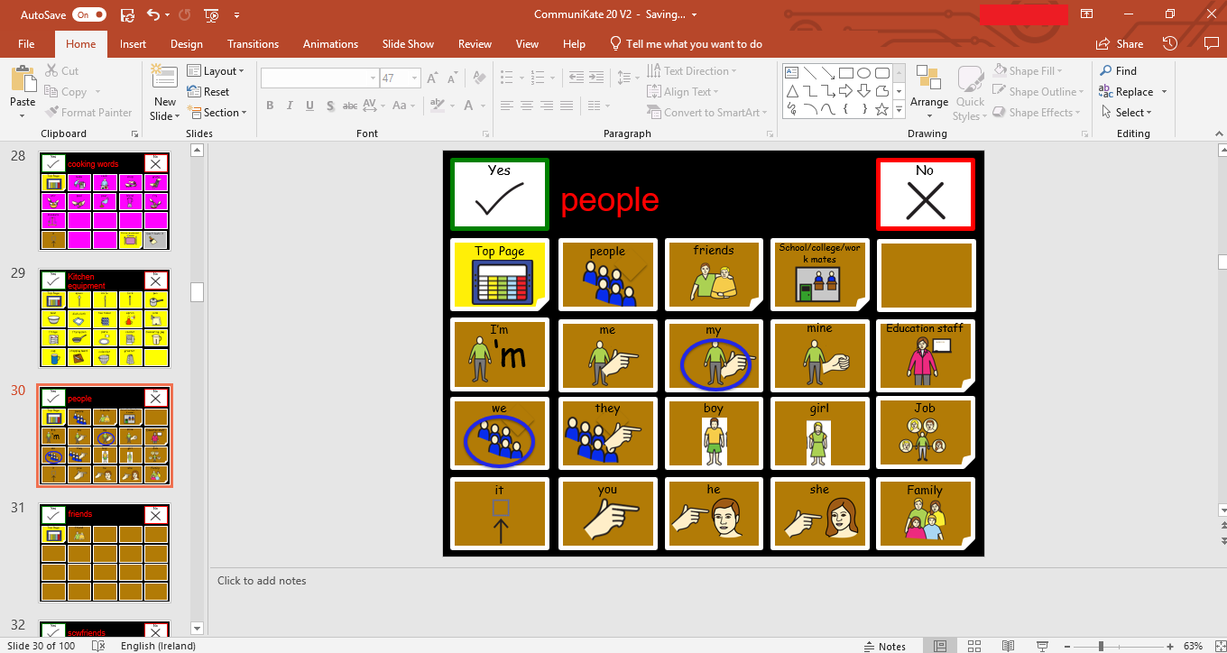

1. Once you are finished all your edits, save the template.
2. Go to the Open Voice Factory website. As the file has been changed it must be reuploaded.
   1. See Guide 1 for more information on uploading a file.
3. Open the link and the pages you have deleted will no longer be present.

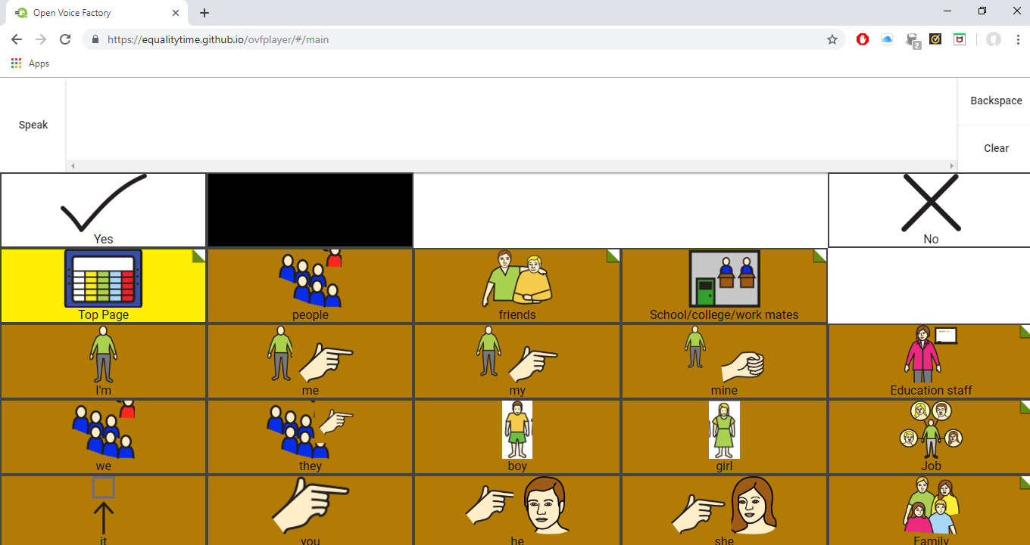

## Guide 4: Adding new pages

1. Open the CommuniKate PowerPoint template downloaded from the Open Voice Factory [website](http://www.theopenvoicefactory.org/). If you are making further edits to a document which you have already made changes to, open the last document you had saved to your computer.



1. Go to the bottom of the PowerPoint document.

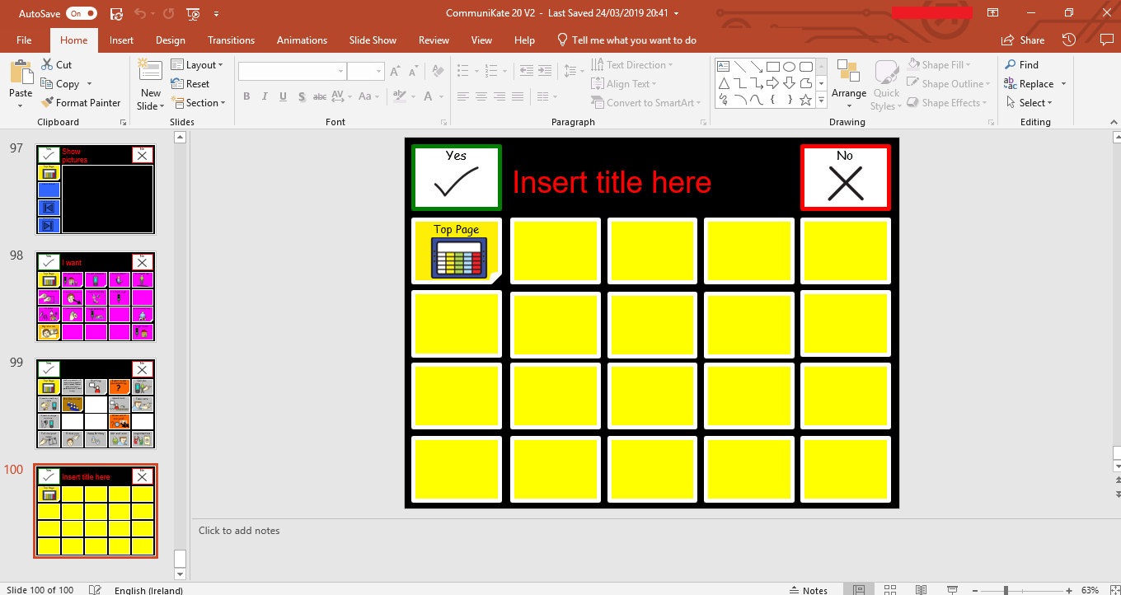

1. Copy the final page on the PowerPoint document.
   1. It should be a blank page, with ‘Insert title here’ on the top.

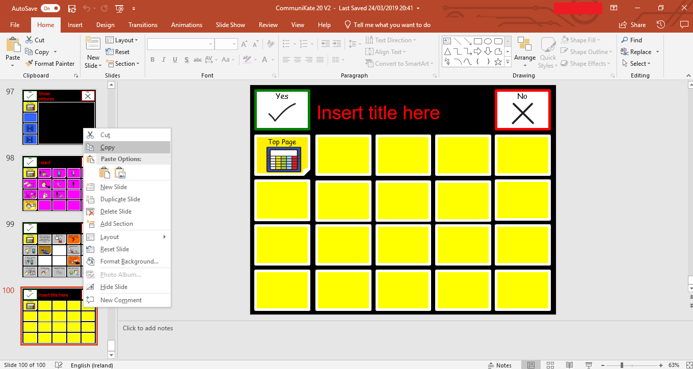

1. Paste the copied page into the document about where you would like it
   1. The actual order of the pages does not matter, it is more for your own understanding of where it can be found.

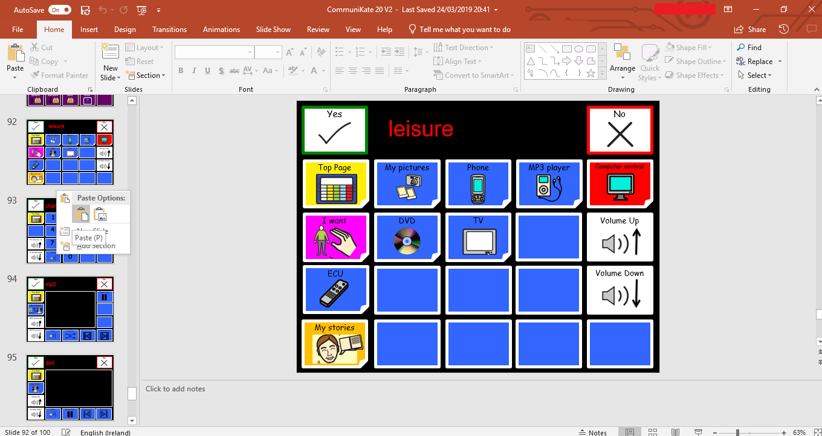

1. Insert title into the top of the page where it says, ‘Insert title here’.
   1. This will be important when trying to link to this page

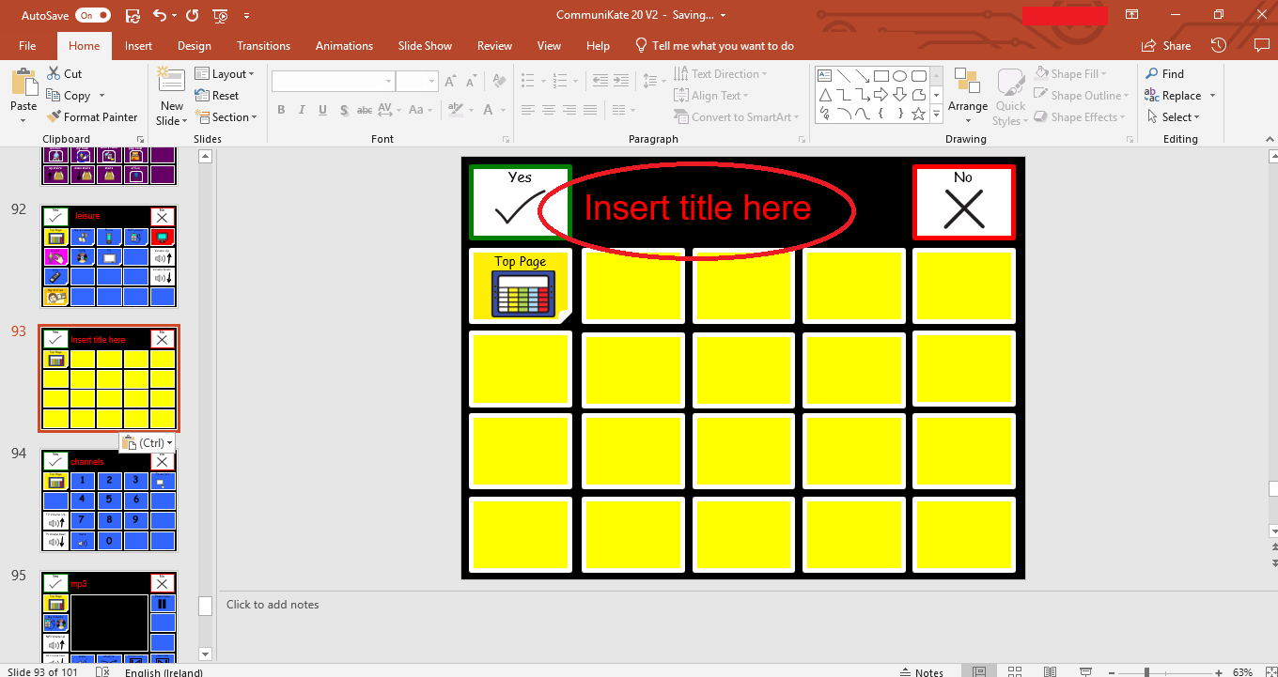

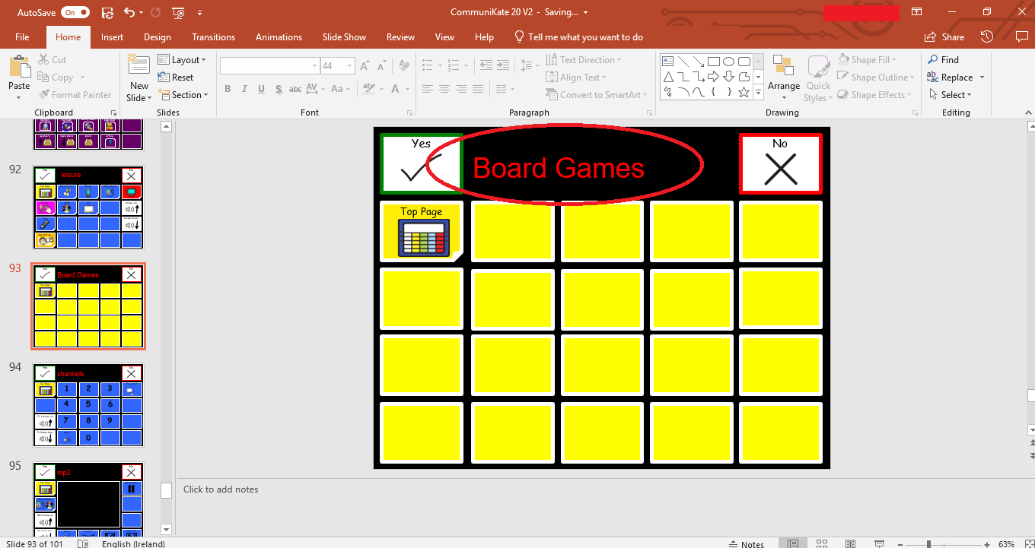

1. Start filling in the words. See Guide 2 for more information about creating a symbol.

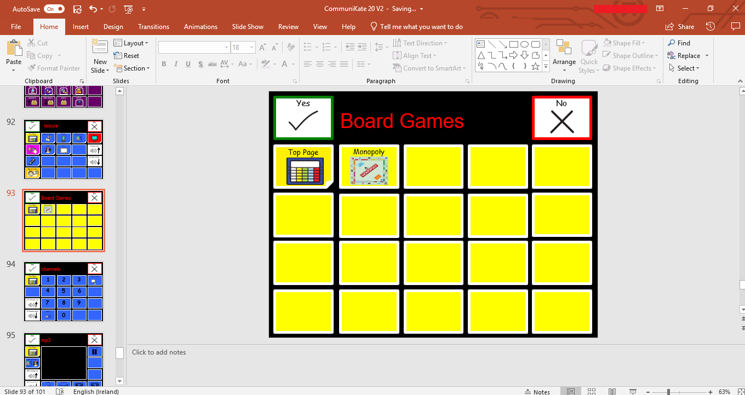

1. Once this page has been completed, see Guide 5 on how to create a link to it.
   1. If you do not create a link to this new page, the person who uses AAC will not be able to access it when using online communication device.

## Guide 5: Creating/Updating Links

1. Open the CommuniKate PowerPoint template downloaded from the Open Voice Factory [website](http://www.theopenvoicefactory.org/). If you are making further edits to a document which you have already made changes to, open the last document you had saved to your computer.



1. Identify the page you are wanting to create a link to, e.g. a new page as created from the information in Guide 4.



1. Identify a place where you want to enter the box which will link to your new page.
2. Delete the box which is currently in that space.

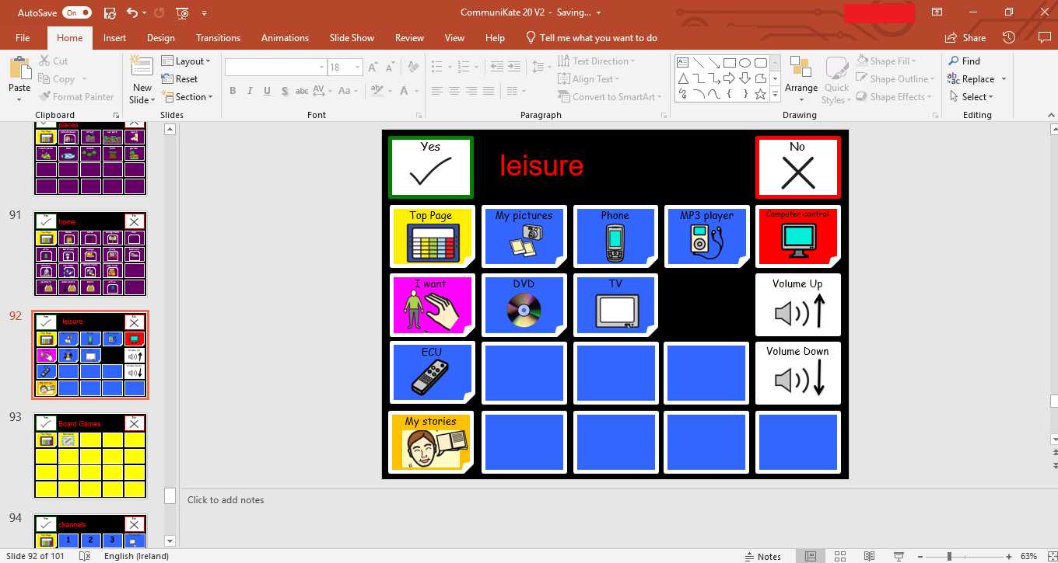

1. Copy and paste a link box (with a folder corner) into the appropriate area.

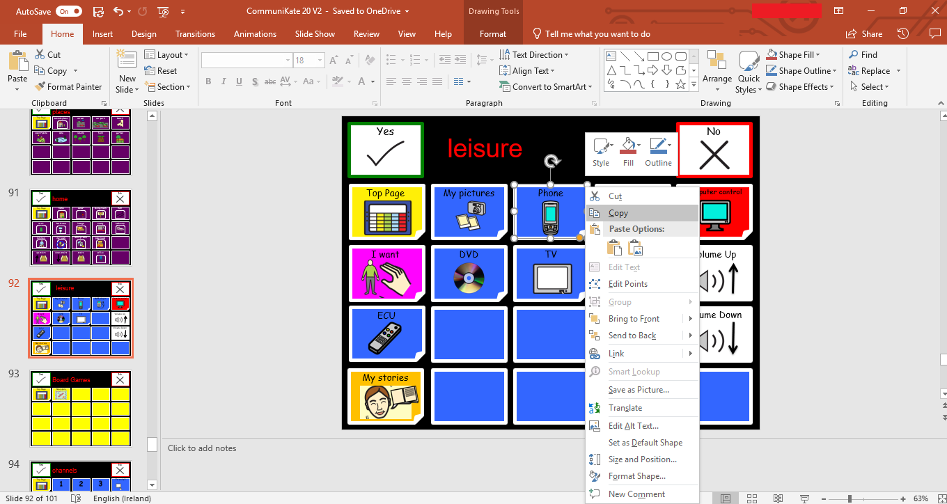

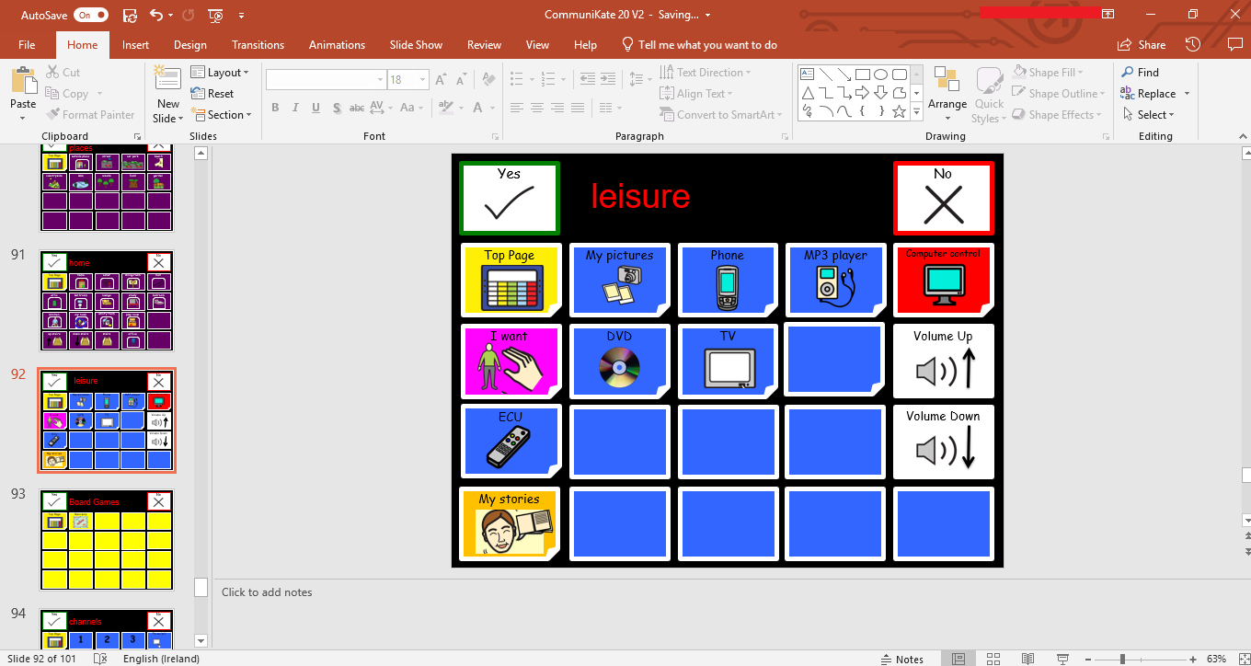

1. Enter the text and icon you would like.

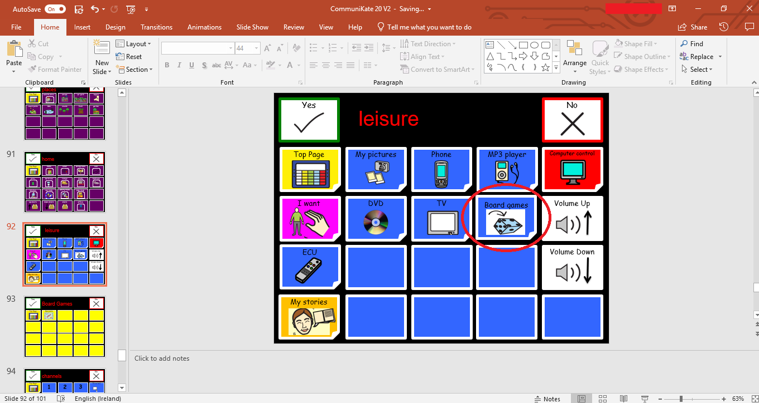

1. Right click on the box (not the text).
2. Select edit link/ edit hyperlink.

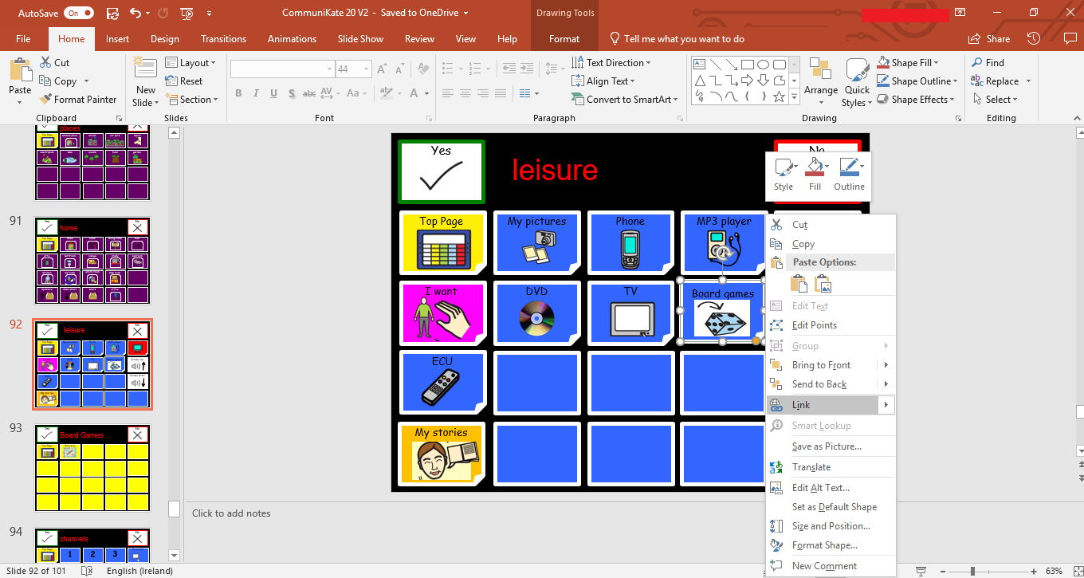

1. Click locate or place in this document (depending on your computer) and find the page you want it to link to.
   1. There may already be a different page linked as this was a copied link box. Ignore this and select your new page.

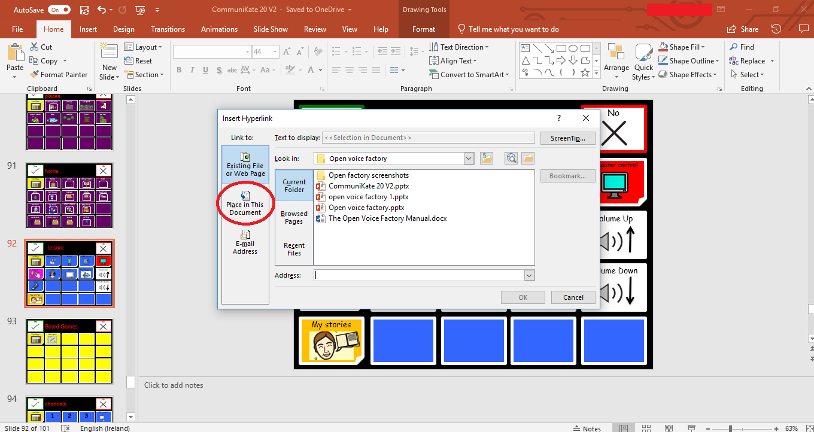

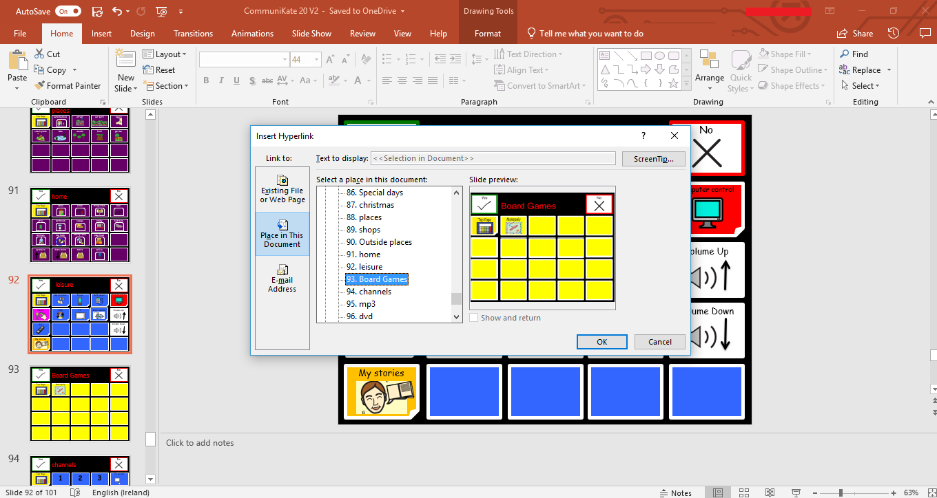

1. Click ok to confirm this.

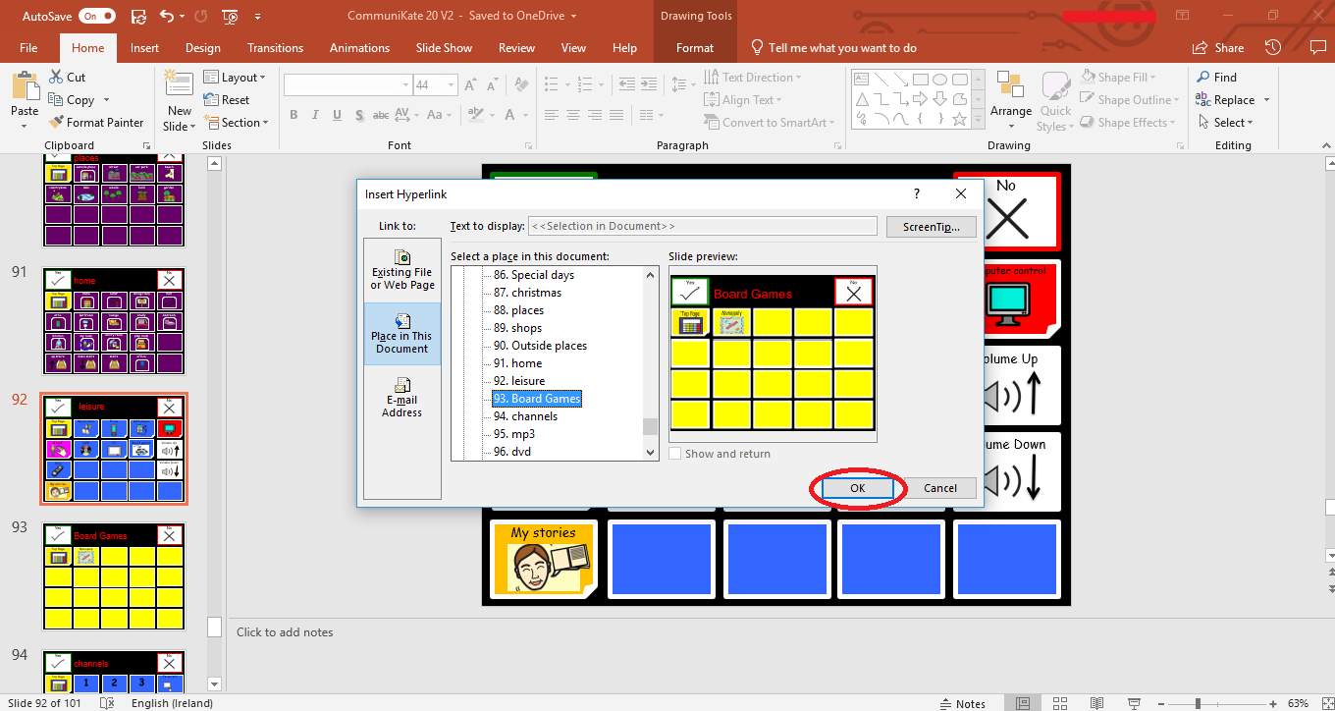

1. Once you are finished all your edits, save the template.
2. Go to the Open Voice Factory website. As the file has been changed it must be reuploaded.
   1. See Guide 1 for more information on uploading a file.
3. Open the link and the new page you have linked will be present.

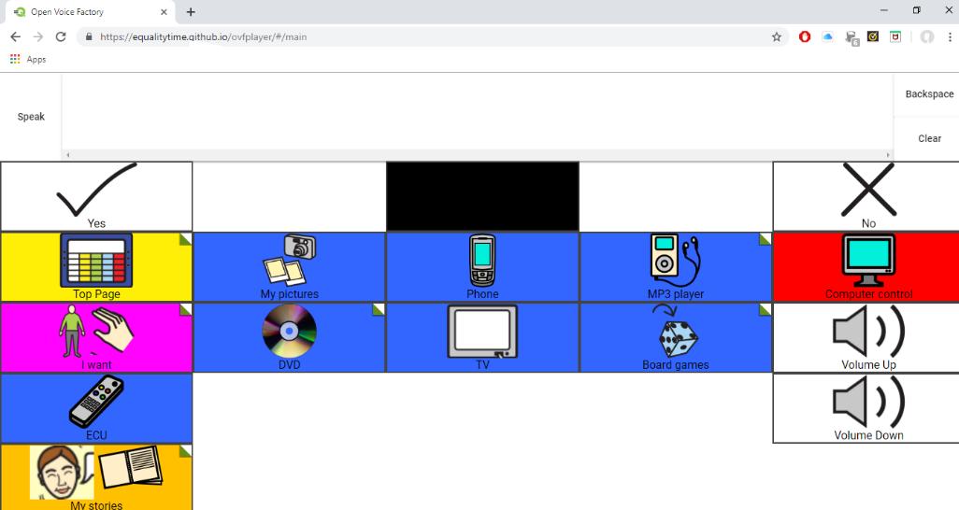

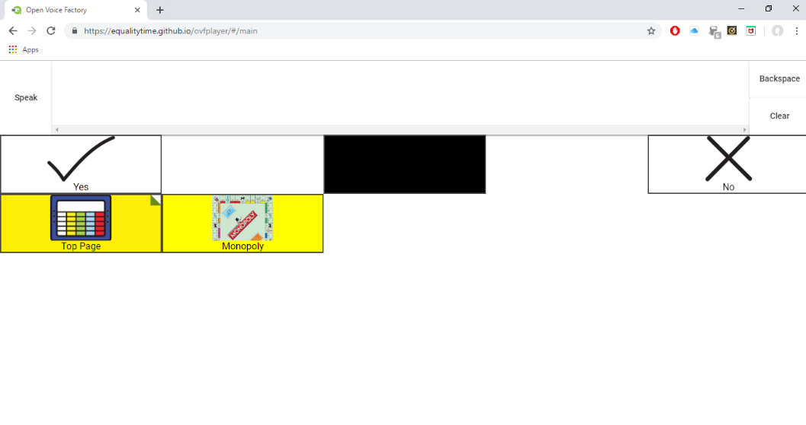

## Guide 6: Special commands on iOS Mac Device

The Open Voice Factory has the ability to insert select special commands to make the buttons do something other than speak the text on them or jump to another page when selected.

To insert a special command:

1. Open the CommuniKate PowerPoint template downloaded from the Open Voice Factory [website](http://www.theopenvoicefactory.org/). If you are making further edits to a document which you have already made changes to, open the last document you had saved to your computer.
2. Identify the box in which you would like to place the link.
3. Right click on the box
4. Select edit hyperlink
5. Edit the information following ‘link to…’
6. Below are a list of the special commands which can be entered into the Open Voice Factory. Each command begins with ovf (for Open Voice Factory) followed by the actual command.
   1. To insert a command to clear the message bar or delete a word:
      1. ovf(clear()) or ovf(deleteword()).
      2. These both have their own pair of brackets following them as they are a function.
   2. To insert a whole phrase into the message bar and not just the label on the button:
      1. ovf(place(“the message you want to put in the message bar goes here”)).
      2. Place is also a function, and this function is to place whatever message comes in the following bracket into the message bar.
   3. To insert a piece of text and jump to a new page at the same time:
      1. ovf(place(“the message you want to put in the message bar goes here”), open(title of the page you want to open)).
      2. As above, the place function places whatever message comes in the following bracket into the message bar. The open function opens the page of which title you placed in the following brackets. You must ensure the title of the page and the word(s) in the brackets match exactly or else it will not open.
7. Once you are finished all your edits, save the template.
8. Go to the Open Voice Factory website. As the file has been changed it must be reuploaded.
   1. See Guide 1 for more information on uploading a file.
9. Open the link and the new special commands you have created will be present.

## Guide 7: Special commands on Windows Device

The Open Voice Factory has the ability to insert select special commands to make the buttons do something other than speak the text on them or jump to another page when selected.

To insert a special command:

1. Open the CommuniKate PowerPoint template downloaded from the Open Voice Factory [website](http://www.theopenvoicefactory.org/). If you are making further edits to a document which you have already made changes to, open the last document you had saved to your computer.



1. Identify the box in which you would like to place the link.
2. Right click on the box
3. Select edit hyperlink
4. Select ‘Existing file or webpage’ on left hand side of pop up box.
5. Enter the command in the box following ‘Address:’
6. Below are a list of the special commands which can be entered into the Open Voice Factory. Each command begins with ovf (for Open Voice Factory) followed by the actual command.
   1. To insert a command to clear the message bar or delete a word:
      1. ovf(clear()) or ovf(deleteword()).
      2. These both have their own pair of brackets following them as they are a function.
   2. To insert a whole phrase into the message bar and not just the label on the button:
      1. ovf(place(“the message you want to put in the message bar goes here”)).
      2. Place is also a function, and this function is to place whatever message comes in the following bracket into the message bar.
   3. To insert a piece of text and jump to a new page at the same time:
      1. ovf(place(“the message you want to put in the message bar goes here”), open(title of the page you want to open)).
      2. As above, the place function places whatever message comes in the following bracket into the message bar. The open function opens the page of which title you placed in the following brackets. You must ensure the title of the page and the word(s) in the brackets match exactly or else it will not open.
7. Once you are finished all your edits, save the template.
8. Go to the Open Voice Factory website. As the file has been changed it must be reuploaded.
   1. See Guide 1 for more information on uploading a file.
9. Open the link and the new special commands you have created will be present.

# Other Open Projects

The Open Voice Factory is not unique in using an open board format. Other such as [CoughDrop](https://www.mycoughdrop.com/) and [Optikey](https://github.com/OptiKey/OptiKey/wiki) have also come around to the thinking that using an open board format is the way forward. Both are fully open-source, allowing for anyone to modify and improve the code. Optikey is also similar to the Open Voice Project in that it is completely free to use. Using an open board format allows for increased sharing of page sets within and across communication software types, and has the added reassurance that if something goes wrong with a certain device, the page set can be run on a different device almost immediately! There is no doubting that an open board format is the future of AAC!

# Appendix

The Open Voice Factory relies on volunteers to do things like test, convert, spot errors, and write documentation. We want to thank all of these people who’ve already made a contribution to either this or the CommuniKate project. We really couldn’t have done it without out you.

• Paulo Ricca

• Brian Whitmer

• David Niemeijer

• Hugo Pacheco

• Will Wade

• Margarida Pinto

• Ian Foulger

• Julie Bello

• Marlene Padrão

• José Danado

• André Nascimento

• Carla Pinto

• Miguel Bento Alves

• Laurine Groux-Moreau

• Maria Hewett

• Paul Hewett

• Gemma Eardley

• Zak Sly

• Stef Armitage

• Alison Carpenter

• Trevor Mobbs

• Diana Mountain

• Fil McIntyre

• Angie McCormac

• Janet Mayers

• Katie Clarke

• Helen Quiller

• Helen Dixon

• Tamsin Crothers

• Megan Hughes

• Anna Flynn

• Janet and Michael Williams

• Joe Reddington

• Kate McCallum

• Kirsty McNaught

• Steve Canny

• Tom Bamber

• Ivona Hristova

• Jaroslav Ryník

The Open Voice Factory is always looking for more people to make a contribution, particular coders, designers, translators and testers. If you like what we are trying to do, please get in touch through our [website](http://www.theopenvoicefactory.org/#create).

# References

Ball, L.J., Beukelman, D.R., Anderson, E., Bilyeu, D.V., Robertson, J., & Pattee, G.L. (2007). Duration of AAC technology use by persons with ALS. Journal of Medical Speech-Language Pathology. 15(4), 371–381.

Creer, S., Enderby, P., Judge, S., & John, A. (2016). Prevalence of people who could benefit from augmentative and alternative communication (AAC) in the UK: determining the need. *Int J Lang Commun Disord, 51*(6), 639-653.

Enderby, P., Judge, S., Creer, S., & John, A. (2013). Examining the Need for and Provision of AAC Methods in the UK. *Advances in Clinical Neuroscience & Rehabilitation*, 13(4), 20-23.

Shepherd, T.A., Cambell, K.A, Renzoni, A.M. & Sloan, N. (2009). Reliability of speech generating devices: A 5-year review. *Augmentative and alternative communication,* *25*(3), 145-153.